UCI CubeSat

EPS Design Report

(Work in Progress)

**1. Objective**

**NEXT STEPS**

* Continue detail on *essential* components that have an input net label from the stm32 along with its output net label and its purpose at a high level.
* Get better screenshots of the schematic *after* some more sheet editing.
* Schematic sheets are not finalized, components will be moving around a bit over time if I feel they should be placed elsewhere.

**2. Block Diagram**

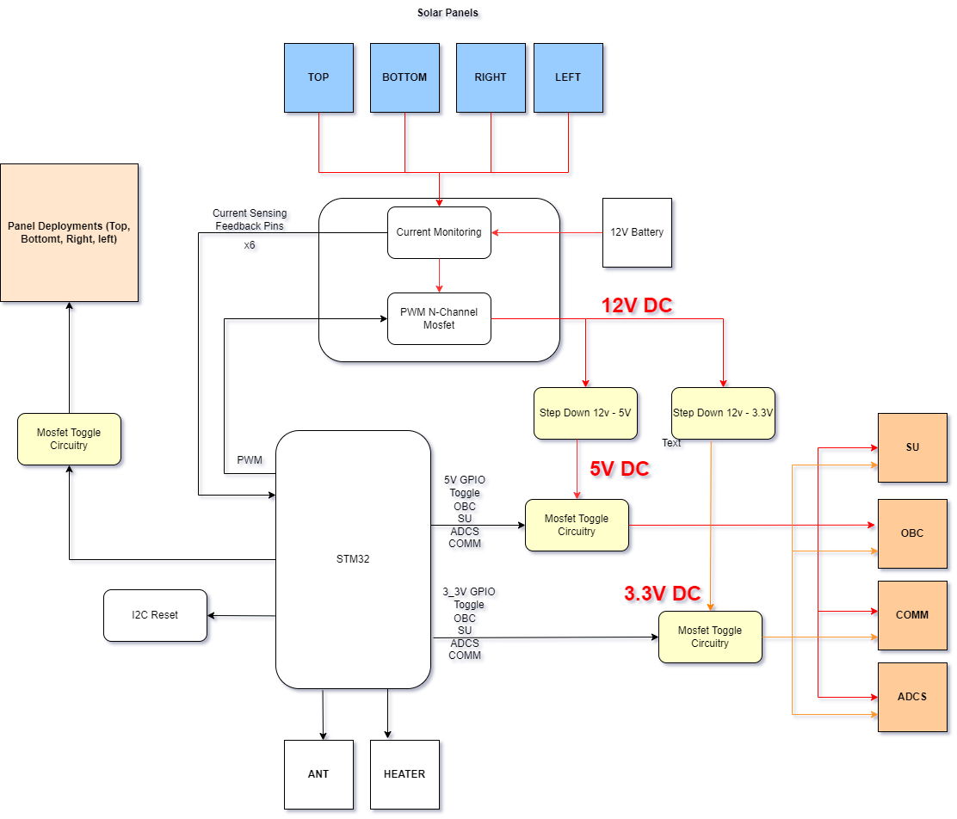

**3. Detailed Block Descriptions**

# **Block 1: no clue atm needs better sheet allocation**

## Design Rationale

## Schematic (Still work in progress)

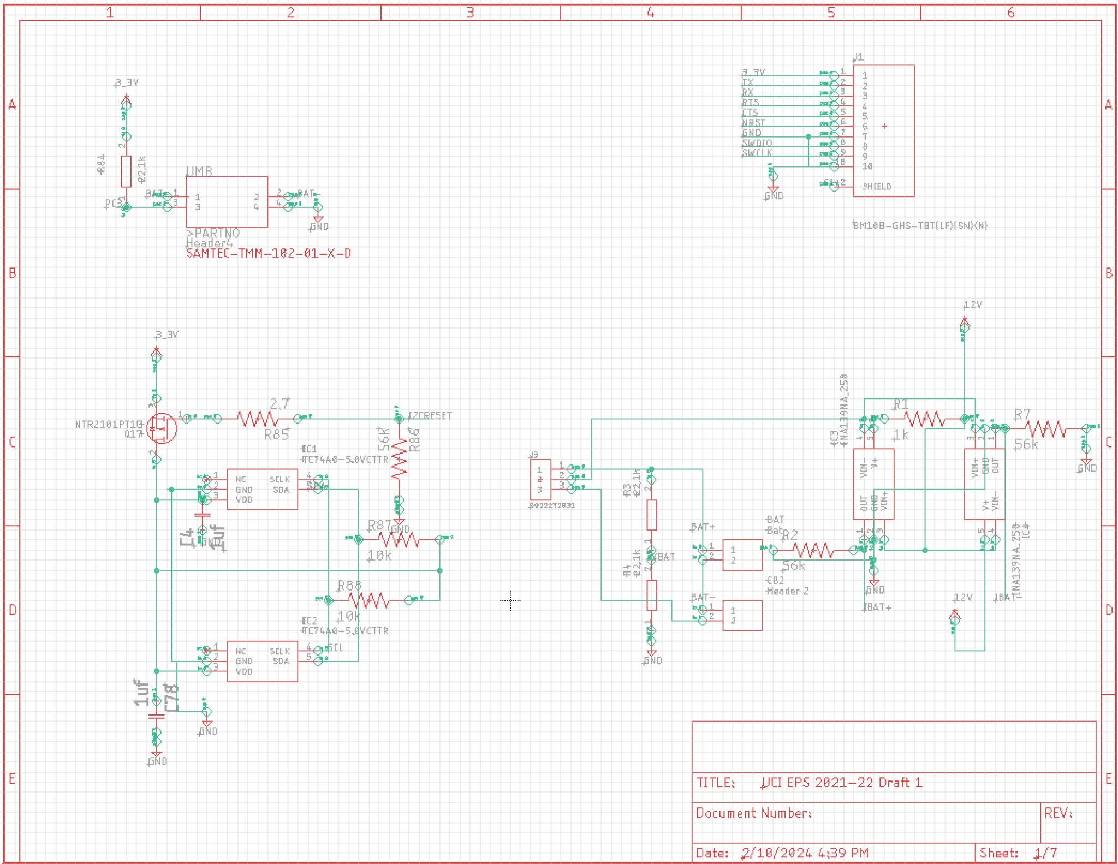

## Component List

| Component Name | Designator | Description |
| --- | --- | --- |
| 0878310441 | UMB | Connector Header Through Hole 4 position 0.079 (2.00mm) |
| TC74A0-5.0VCTTR | IC1,IC2 | SENSOR DIGITAL -40C-125C SOT23-5 |
| 22272031 | J3 | CONN HEADER VERT 3POS 2.54MM |
| BM10B-GHS-TBT(LF)(SN)(N) | J1 | CONN HEADER SMD 10POS 1.25MM |
| 22272021 | BAT,CB2, | CONN HEADER VERT 2POS 2.54MM |
| INA139NA/250 | IC3,IC4 | IC CURRENT MONITOR 0.5% SOT23-5 |
| NTR2101PT1G | Q17 | MOSFET P-CH 8V SOT23-3 |

## Functional Description

| Purpose | Component | Input Net label | Output Net Label |
| --- | --- | --- | --- |
|  |  |  |  |

# 

# **Block 2: Solar Panel Power Generation**

## Design Rationale

Manages power generation from our solar panels along with providing the STM32 and the software team data about current characteristics throughout its deployment.

Incoming solar panel current is monitored using the INA139NA IC by converting the input current to something more manageable for the STM32.

Power generation is controlled through a PWM signal into a discrete Buck Converter set up using the **PWM1-4** netlabels tied to STM32 pins. It is important to note that buck converter diodes are found within the FDFS6N548 N-Channel Mosfet. Solar Panel connectors are also found here.

## Schematic

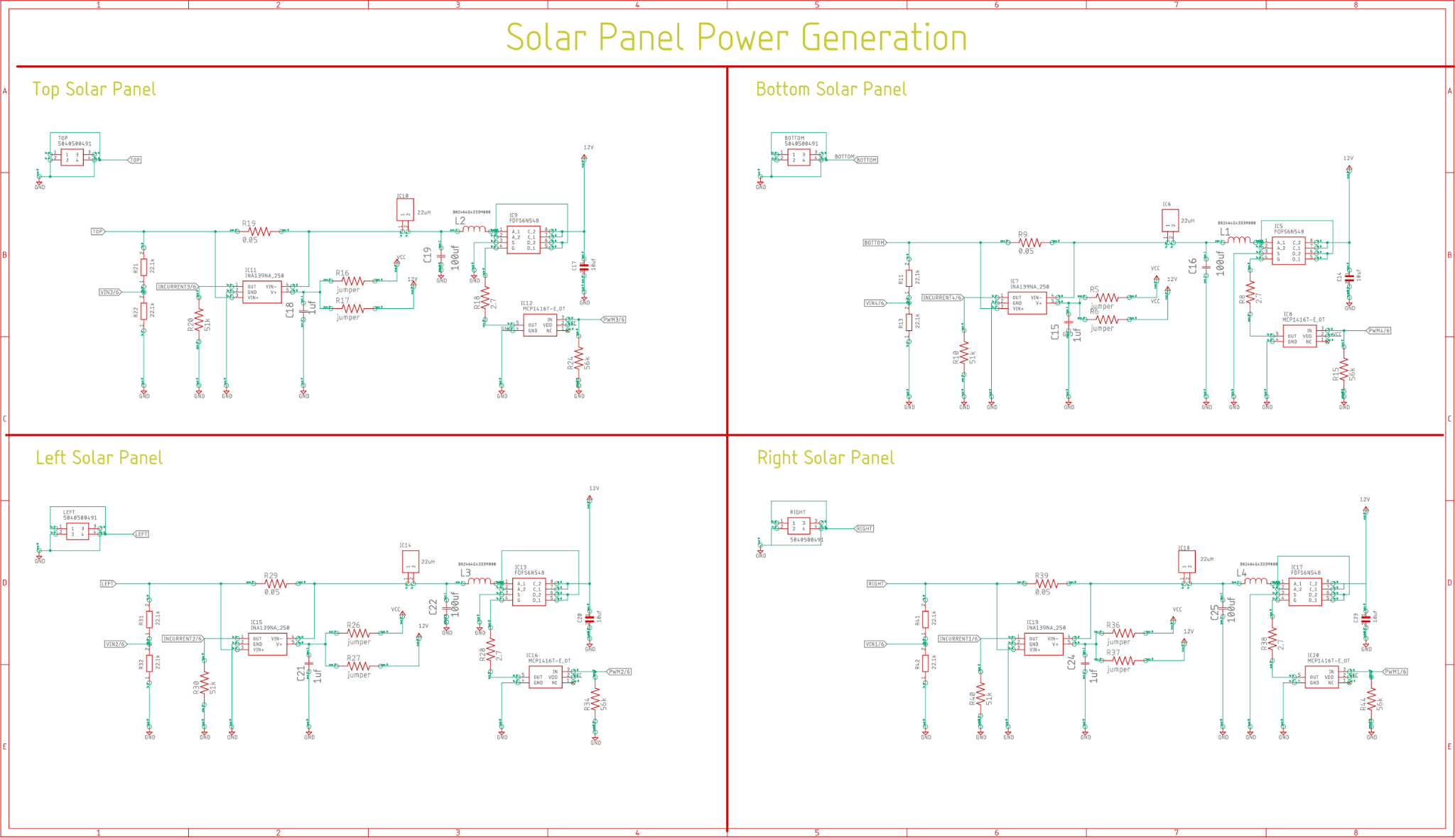

## 

## Functional Description

| Purpose | Component | Designators | Input Net label | Output Net Label |
| --- | --- | --- | --- | --- |
| Monitors current generation from **TOP** solar panel for data acquisition and power control | INA139NA/250 | IC11 | **TOP** | **INCURRENT3** |
| Monitors current generation from **BOTTOM** solar panel for data acquisition and power control | INA139NA/250 | IC7 | **BOTTOM** | **INCURRENT4** |
| Monitors current generation from **RIGHT** solar panel for data acquisition and power control | INA139NA/250 | IC19 | **RIGHT** | **INCURRENT1** |
| Monitors current generation from **LEFT** solar panel for data acquisition and power control | INA139NA/250 | 15 | **LEFT** | **INCURRENT2** |

## Component List

| Component Name | Designator | Description |
| --- | --- | --- |
| INA139NA/250 | IC7,IC11,IC15,IC19 | IC CURRENT MONITOR 0.5% SOT23-5 |
| SRU8043-220Y | IC6,IC10,IC14,IC18 | FIXED IND 22UH 2.2A 72.5MOHM SMD |
| FDFS6N548 | IC5,IC9,IC13,IC17 | MOSFET N-CH 30V 7A 8SOIC |
| MCP1416T-E/OT | IC8,IC12,IC16,IC20 | IC GATE DRVR LOW-SIDE SOT23-5 |

# **Block 3: (Need Name)**

## Design Rationale

## Schematic

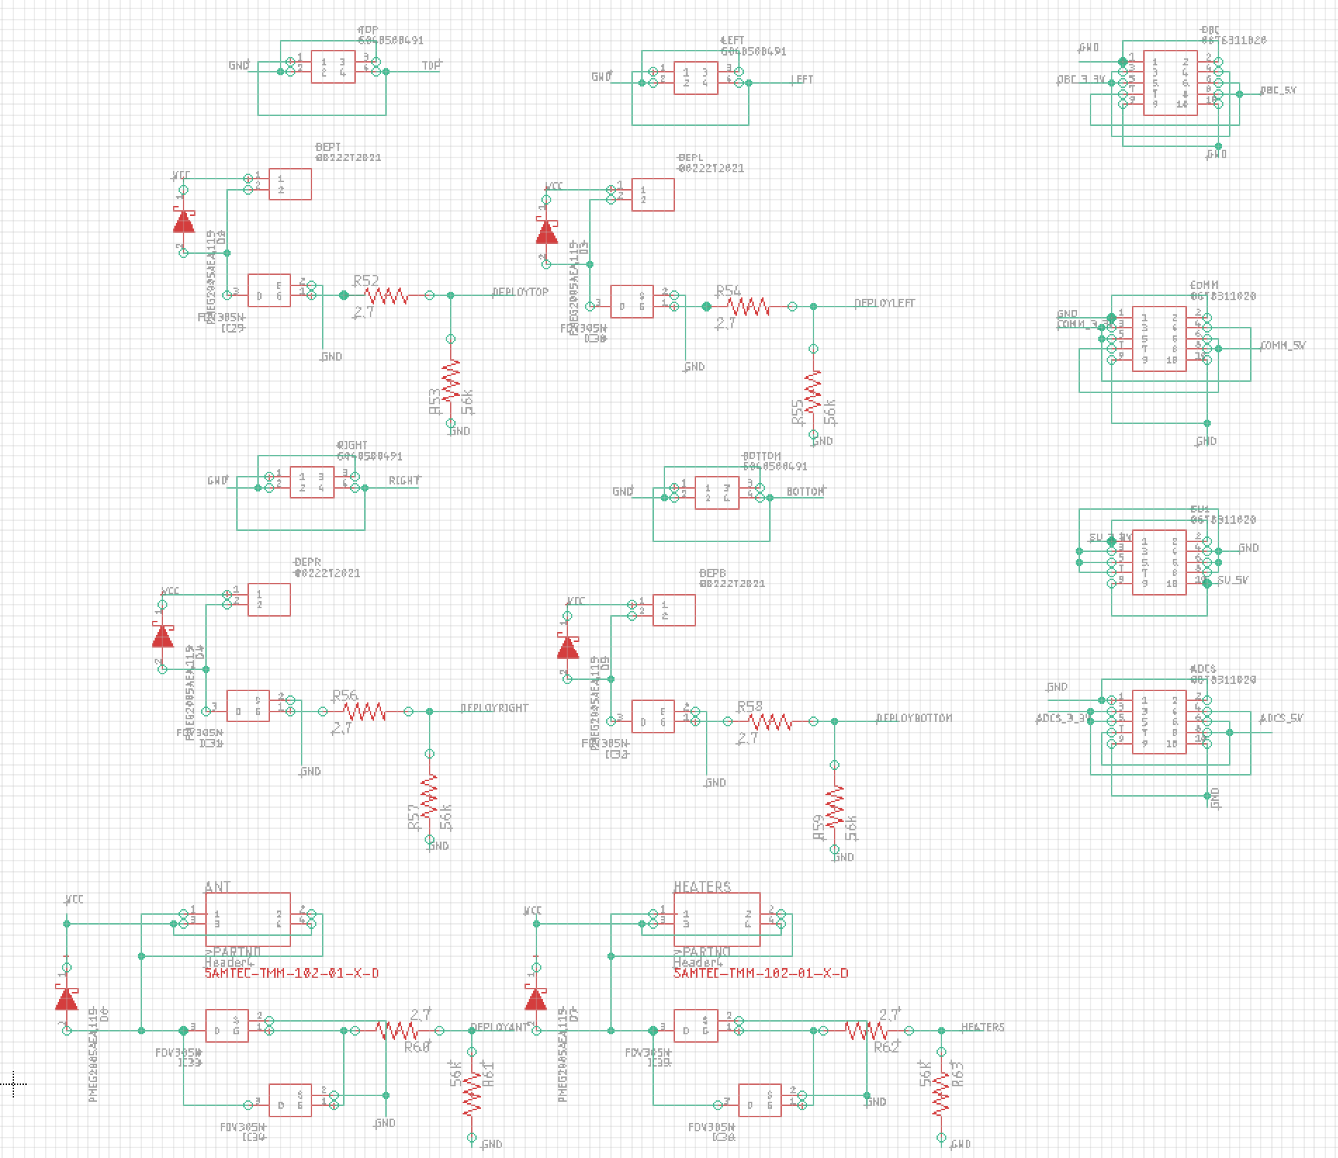

## Functional Description

| Purpose | Component | Designators | Input Net label | Output Net Label |
| --- | --- | --- | --- | --- |
| Need Description | FDV305N | IC29 | **DEPLOYTOP** | **No net label, N-Channel IC29** |
| Need Description | FDV305N | IC32 | **DEPLOYBOTTOM** | **No net label, output from N-Channel IC32** |
| Need Description | FDV305N | IC31 | **DEPLOYRIGHT** | **No net label, output from N-Channel IC31** |
| Need Description | FDV305N | IC30 | **DEPLOYLEFT** | **No net label, output from N-Channel IC30** |
| Need Description | FDV305N | IC33, IC34 | **DEPLOYANT** | **No net label, output from N-Channel IC33-34** |
| Need Description | FDV305N | IC35, IC36 | **HEATERS** | **No net label, output from N-Channel IC35-36** |

## Component List

| Component Name | Designator | Description |
| --- | --- | --- |
| FDV305N | IC29,IC30,IC31,IC32,IC33,IC34,IC35,IC36 | N-Channel 20 V 900mA (Ta) 350mW (Ta) Surface Mount SOT-23-3 |
| 0878310441 | ANT,HEATERS | Connector Header Through Hole 10 position 0.079 (2.00mm) |
| 878311020 (MOVE TO SHEET 5 (Block 4) | ADCS,COMM,OBC,SU1 | Connector Header Through Hole 10 position 0.079 (2.00mm) |
| 22272021 | DEPB,DEPL,DEPR,DEPT | CONN HEADER VERT 2POS 2.54MM |
| 5040500491 (MOVE TO SHEET 2) | BOTTOM,LEFT,RIGHT,TOP | CONN HEADER SMD R/A 4POS 1.5MM |

# 

# **Block 4: Power Distribution Management**

## Design Rationale

To supply separate subsystems with their own 3.3V and 5V rails, the main 12V power supply voltage rail is efficiently converted into individual rails using a 3A compatible TPS54331GDR Buck converter. The current drawn from these voltage rails are then monitored using the INA139NA current monitor IC and fed back into the STM32 for data acquisition and systems control using the I5V and I3_3V net labels.

N-channel mosfets are then toggled on and off using STM32 GPIO signals to enable power to the desired subsystem. It is important to note that both 5V and 3.3V are either on or off at the same time for each subsystem. This is due to the fact that ONOFF net labels are followed by ONOFF2 labels which are inputted into a low-side gate driver for the 5V subsystem power rails.

## Schematic

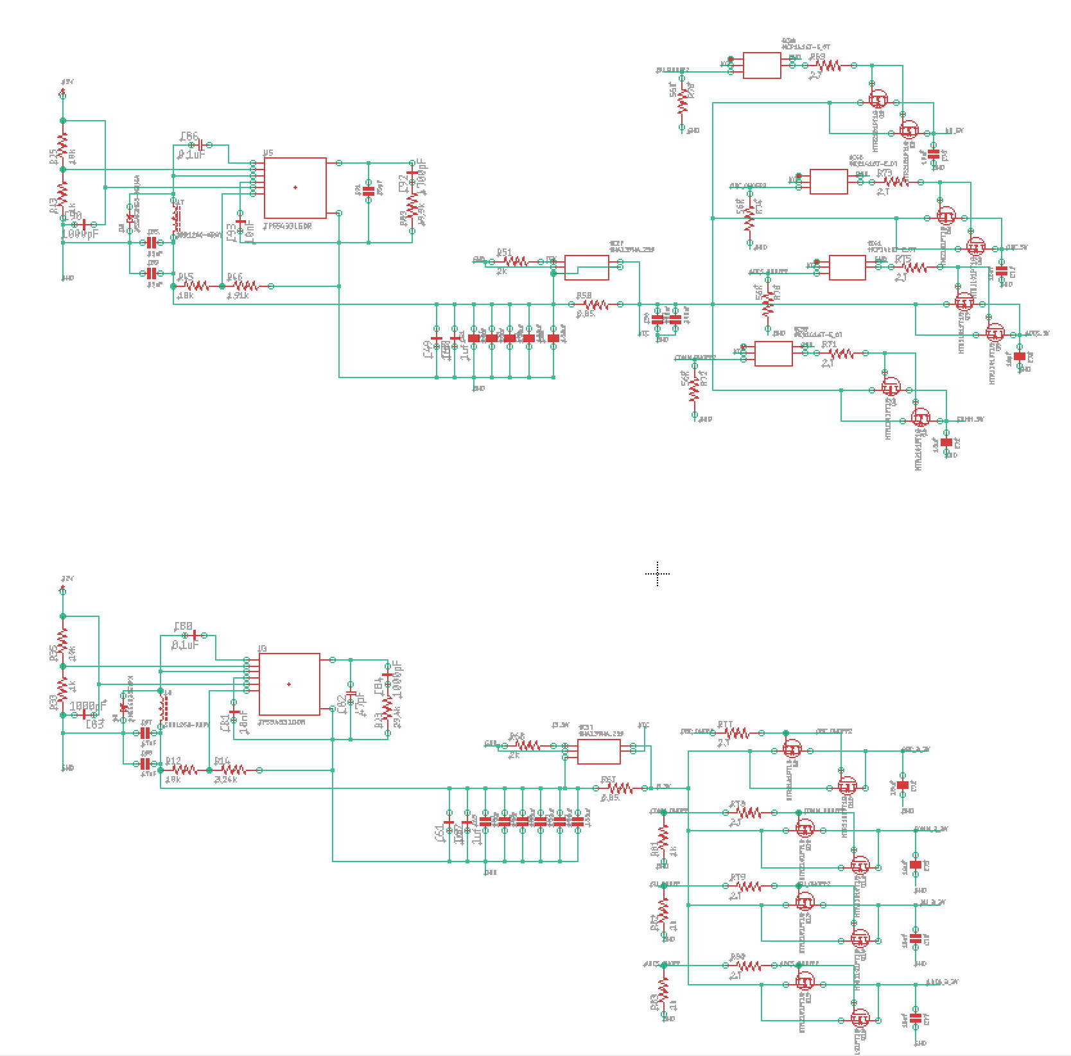

## Functional Description

| Purpose | Component | Designator | Input Net label | Output Net Label |
| --- | --- | --- | --- | --- |
| 12V -> 3.3V Converter | INA139NA/250 | IC37 | **No label, input from Buck regulator U3** | I3_3V |
| 12V -> 5V Converter | INA139NA/250 | IC28 | **No label, input from Buck regulator U5** | I5V |
| Toggle OBC 3.3V Rail | NTR2101PT1G | Q9,Q10, | **OBC_ONOFF** | OBC_3_3V |
| Toggle COMM 3.3V Rail | NTR2101PT1G | Q11,Q12, | **COMM_ONOFF** | COMM_3_3V |
| Toggle SU 3.3V Rail | NTR2101PT1G | Q13,Q14, | **SU_ONOFF** | SU_3_3V, |
| Toggle ADCS 3.3V Rail | NTR2101PT1G | Q15,Q16, | **ADCS_ONOFF** | ADCS_3_3V |
| Note: **OBC_ONOFF2** and beyond are derived from their original net, relayed to activate 5V rails using MCP1416T-E/OT Components  Question: Is there only a single toggle to activate 5v and 3.3v at the same time instead of individually? | | | | |
| Toggle OBC 5V Rail | NTR2101PT1G | Q1,Q2 | **OBC_ONOFF2** | OBC_5V |
| Toggle COMM 5V Rail | NTR2101PT1G | Q3,Q4 | **COMM_ONOFF2** | COMM_5V |
| Toggle SU 5V Rail | NTR2101PT1G | Q5,Q6 | **SU_ONOFF2** | SU_5V |
| Toggle ADCS 5V Rail | NTR2101PT1G | Q7,Q8 | **ADCS_ONOFF2** | ADCS_5V |

## Component List

| Component Name | Designator | Description |
| --- | --- | --- |
| TPS54331GDR | U3,U5 | IC REG BUCK ADJUSTABLE 3A 8SOIC |
| INA139NA/250 | IC37, IC28 | IC CURRENT MONITOR 0.5% SOT23-5 |
| MCP1416T-E/OT | IC38,IC39, IC40,IC41 | IC GATE DRVR LOW-SIDE SOT23-5 |
| NTR2101PT1G | Q1,Q2,Q3,Q4,Q5,Q6,Q7,Q8,Q9,Q10,Q11,Q12,Q13,Q14,Q15,Q16, | MOSFET P-CH 8V SOT23-3 |

# **Block 5: STM32**

## Design Rationale

## Schematic

## Pin Description

| Purpose | Pin | Pin Name | Net Label |
| --- | --- | --- | --- |
|  | 15 | PA1 | VBAT |
|  | 16 | PA2 | IBAT+ |
|  | 17 | PA3 | IBAT- |
| Monitors 3.3V Rail Current Draw | 20 | PA4 | I3_3V |
| Monitors TOP Solar Panel Current Generation | 21 | PA5 | INCURRENT3 |
| Monitors TOP Solar Panel Voltage?? | 22 | PA6 | VIN3 |
| Buck Reg. Pulse Generation (LEFT Solar Panel) | 23 | PA7 | PWM2 |
|  | 41 | PA8 | HEATERS |
|  | 44 | PA11 | CTS |
|  | 45 | PA12 | RTS |
|  | 46 | PA13 | SWDIO |
|  | 49 | PA14 | SWCLK |
| Buck Reg. Pulse Generation (TOP Solar Panel) | 26 | PB0 | PWM3 |
| Buck Reg. Pulse Generation (RIGHT Solar Panel) | 27 | PB1 | PWM1 |
|  | 28 | PB2 | I2CRESET |
| Toggles Comms Power Rails | 5 |  | COMM_ONOFF |
|  | 6 |  | DEPLOYLEFT |
| Monitors LEFT Solar Panel Voltage?? | 8 | PC0 | VIN2 |
| Monitors LEFT Solar Panel Current Generation | 9 | PC1 | INCURRENT2 |
| Monitors 5V Current Draw | 10 | PC2 | I5V |
|  | 11 | PC3 | PC3 |
|  | 25 | PC5 | DEPLOYTOP |
| Buck Reg. Pulse Generation (BOTTOM Solar Panel) | 37 | PC6 | PWM4 |
|  | 39 | PC8 | DEPLOYANT |
|  | 40 | PC9 | DEPLOYRIGHT |
|  | 51 | PC10 | TX |
|  | 52 | PC11 | RX |
| Toggles SU Power Rails | 2 |  | SU_ONOFF |
| Toggles OBC Power Rails | 3 |  | OBC_ONOFF |
| Toggles ADCS Power Rails | 4 |  | ADCS_ONOFF |
|  | 7 | NRST | NRST |
|  | 61 | PB8 | DEPLOYBOTTOM |
|  | 29 | PB10 | SCL |
|  | 30 | PB11 | SDA |
| Monitors RIGHT Solar Panel Current Generation | 33 | PB12 | INCURRENT1 |
| Monitors RIGHT Solar Panel Voltage?? | 34 | PB13 | VIN1 |
| Monitors BOTTOM Solar Panel Current Generation | 35 | PB14 | INCURRENT4 |
| Monitors BOTTOM Solar Panel Voltage?? | 36 | PB15 | VIN4 |